Infosys Springboard Virtual Internship 6.0
Completion Report
- Project Title
Food Trends Understanding Customer Preferences in FB
- Project Objective
- To collect and integrate customer feedback from surveys, social media platforms, and product reviews into a unified dataset.
- To analyze customer feedback using sentiment analysis to classify opinions as positive, neutral, or negative.
- To provide a centralized view of customer sentiment across different products and regions.
- To identify the most liked and most criticized product features such as taste, price, and packaging.
- To detect important keywords and themes from unstructured customer feedback.
- To segment customers based on satisfaction level, feedback frequency, and preferences.
- To generate actionable insights and strategy recommendations for product innovation and marketing campaigns.
- Project description
FoodTrends is a data analytics and visualization project designed to transform raw customer feedback into meaningful business insights. Customer opinions collected through Google Forms surveys, online reviews, and social media platforms are integrated into a centralized system. Unstructured feedback is collected using Apify tools such as the Facebook Comments Scraper and Review Scraper. The collected datasets are cleaned, standardized, and analyzed using sentiment analysis and behavioral clustering techniques.

The project focuses on identifying what customers like and dislike about food products, such as taste, price, packaging, and availability. Interactive dashboards built in Power BI present trends in customer sentiment, product performance, and regional preferences. The insights generated help stakeholders identify improvement areas, track customer satisfaction, and plan data-driven marketing and product strategies.

- System Architecture
The FoodTrends system follows a layered architecture:
- Data Sources:
Google Forms survey data and unstructured feedback from social media and review platforms collected using Apify (CSV/API)
- Data Transformation:
Power Query in Power BI for data cleaning and integration, along with Python-based NLP processing using TextBlob for sentiment analysis
- Semantic Model:
Customer, Product, Feedback, Region, and Time dimensions with sentiment labels and sentiment scores
- Visualization Layer:
Power BI dashboards for sentiment analysis, product insights, customer segmentation, and strategy & innovation

- Project Execution Details

The FoodTrends project was carried out in a structured and systematic manner. Initially, customer feedback data was collected and consolidated into a single dataset. The collected data was then cleaned and organized to remove inconsistencies and ensure accuracy for analysis.

After data preparation, sentiment analysis was performed to understand customer opinions and satisfaction levels. Feedback was categorized into positive, neutral, and negative sentiments, and sentiment scores were generated to measure the intensity of customer responses.

The analyzed data was then used to create interactive dashboards in Power BI. These dashboards visualized customer sentiment trends, product performance, regional preferences, and customer behavior patterns. Finally, the insights obtained from the dashboards were interpreted to derive meaningful conclusions and actionable recommendations to support product improvement, marketing strategies, and innovation decisions.

- Snapshots / Screenshots

This section presents snapshots of the data sources, processing steps, and prepared datasets used in the FoodTrends project.

Unstructured Data
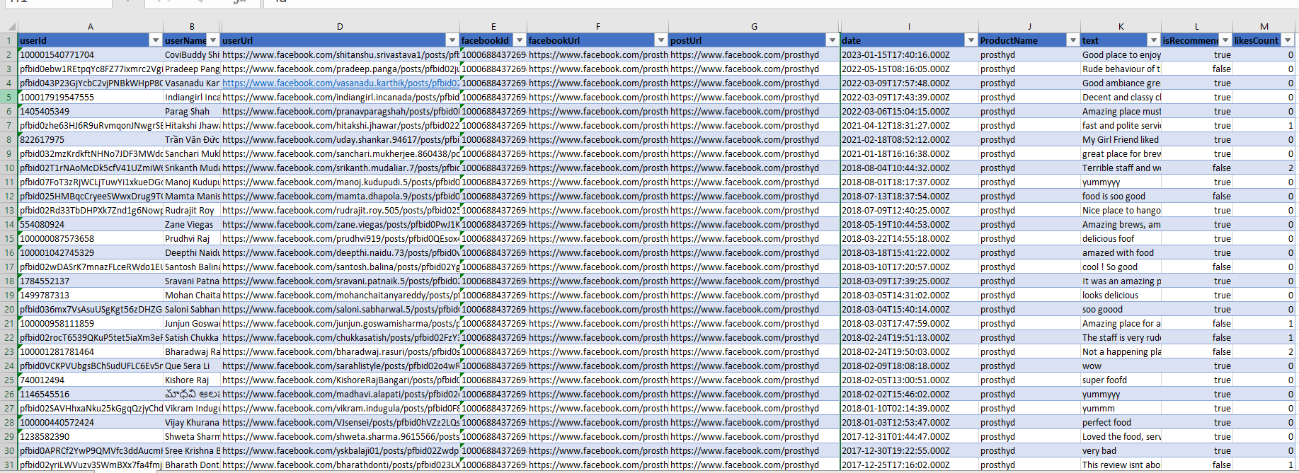

Structured Data

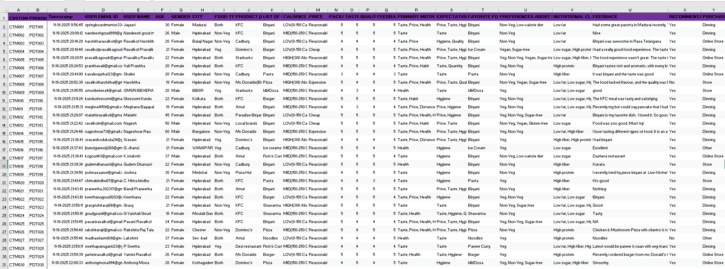

NLP Script

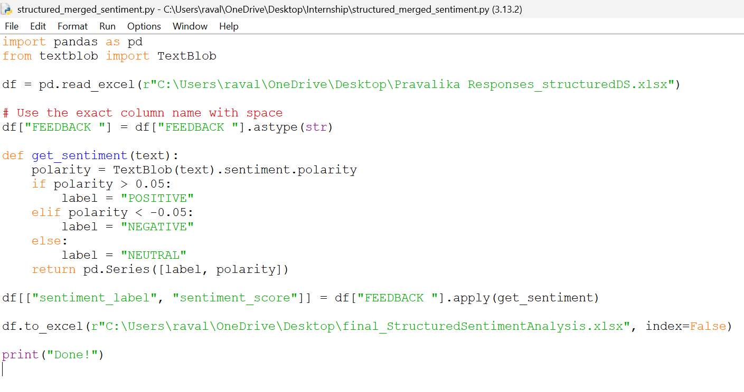

Dataset with Sentiment Score and Label

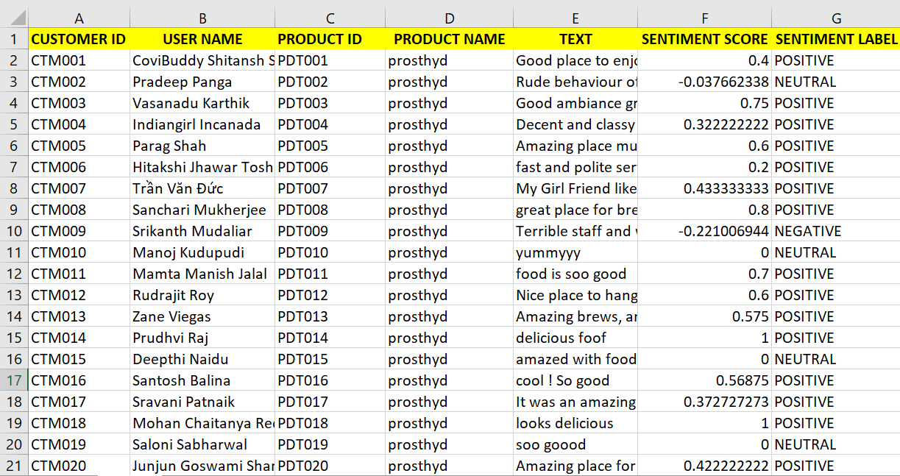

- Semantic Model

The Food trends semantic model in Power BI organizes structured and unstructured feedback data into a central Feedback_Table connected to Customer, Product, and Date dimension tables. Separate tables for Structured (survey) and Unstructured (social/review) data are linked to enable cross-analysis.

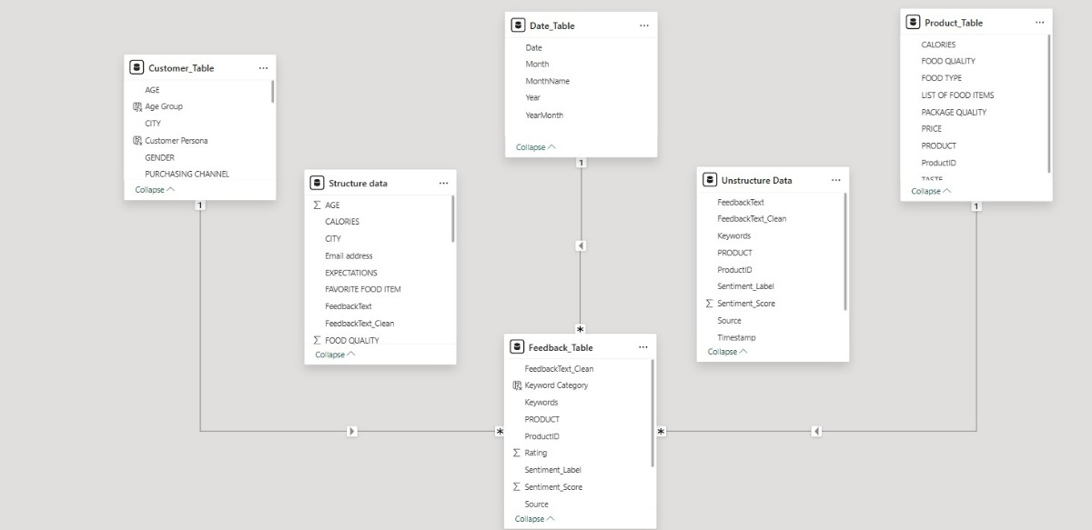

- Modules Implemented & Dashboards Developed

  - Sentiment Analysis Module

- Classified customer feedback into positive, neutral, and negative sentiments
- Calculated sentiment scores and positive feedback ratios using DAX
- Visualized sentiment trends by product, feature, and region

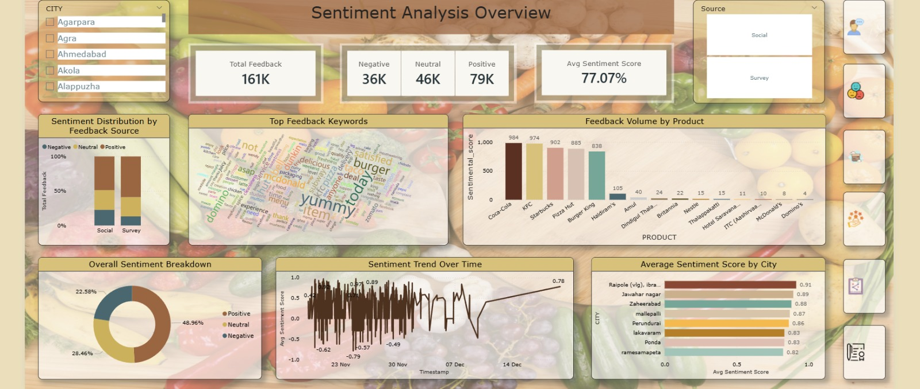

  - Product Insights Module

- Compared product categories based on ratings and sentiment scores
- Analyzed key attributes such as taste, price, packaging, and quality
- Identified correlations between customer sentiment and product performance
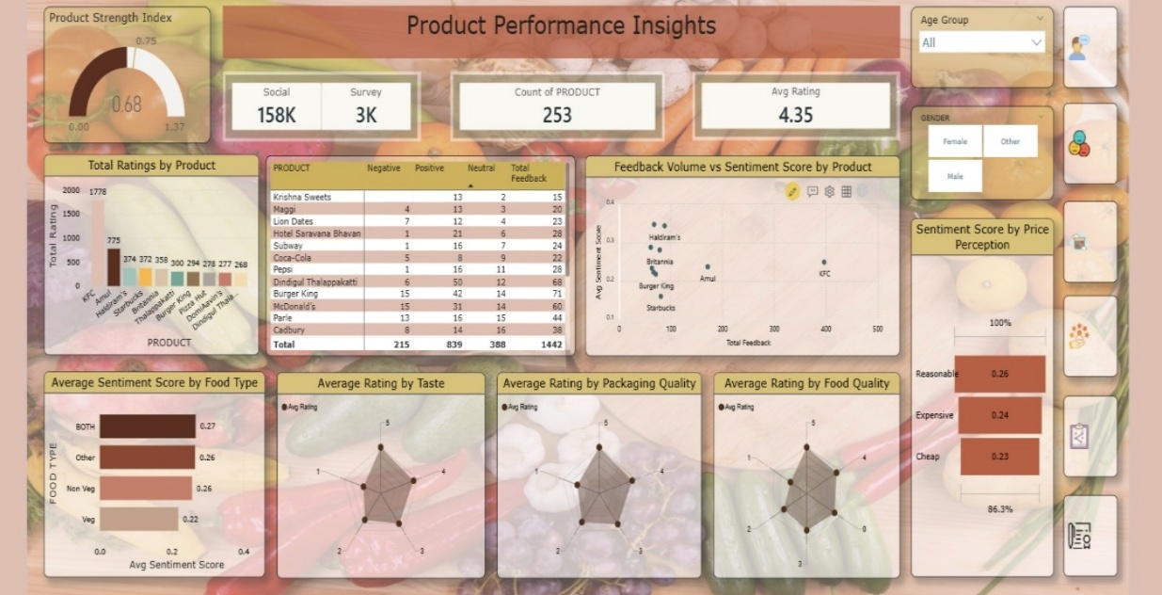

  - Customer Segmentation Module

- Segmented customers into personas such as Loyal Customers, Critics, and Silent Users
- Clustered users based on sentiment behavior, feedback frequency, and preferences
- Enabled filters by region, age group, and purchasing channel

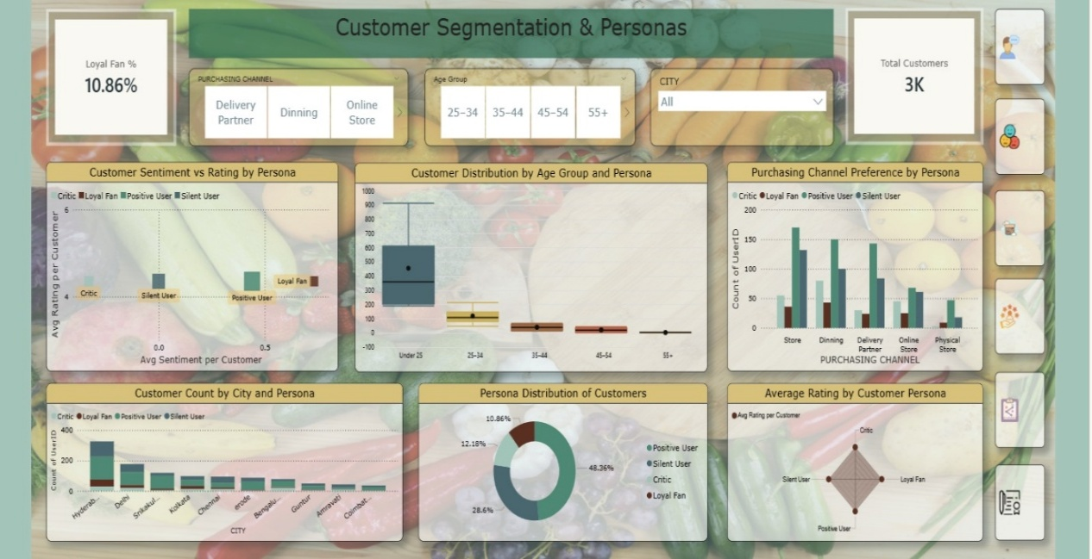

4. Strategy & Innovation Dashboard
- Identified trending keywords and recurring customer concerns
- Highlighted opportunities for marketing campaigns and product innovation
- Monitored sentiment changes before and after product launches

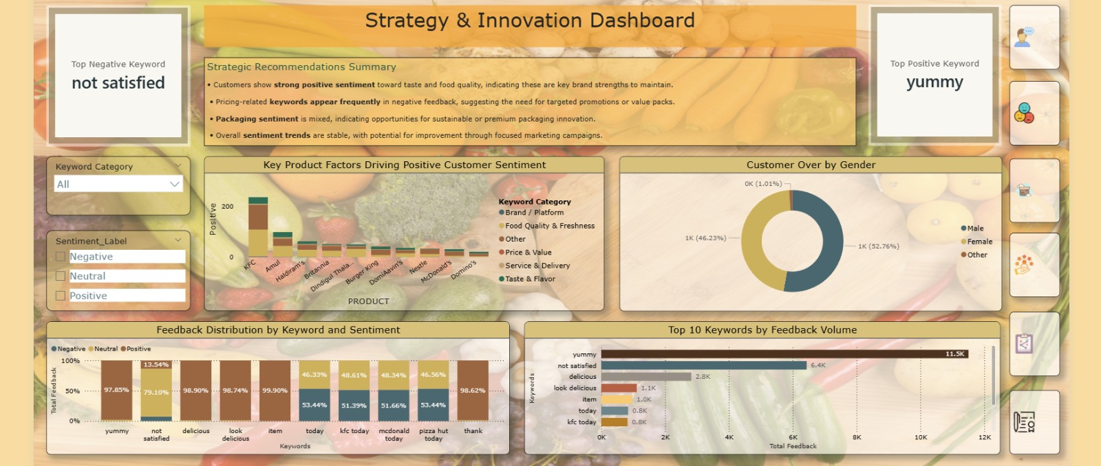

- Challenges Faced

- Data Collection – Gathering feedback from multiple sources and formats was time-consuming and inconsistent.

- Sentiment Analysis Precision – Accurately identifying positive, negative, and neutral sentiments was challenging due to mixed emotions, informal language, and context-dependent words in customer feedback.

- Aspect Creation – Identifying key aspects like Overall Experience, Staff, Food, Ambience, and Quality required careful categorization.

- Keyword Extraction – Extracting meaningful keywords from reviews to highlight important insights was challenging due to noisy text.

- Learnings & Skills Acquired

- Data Collection & Cleaning – Learned to collect data from multiple sources and preprocess unstructured text data.
- NLP & Sentiment Analysis – Gained hands-on experience in applying NLP techniques to generate sentiment scores and labels.
- Aspect-Based Analysis – Developed skills in creating and analyzing aspects such as Overall Experience, Staff, Food, Ambience, and Quality.
- Keyword Extraction – Learned to extract meaningful keywords from customer feedback to identify key trends and issues.
- Data Visualization – Improved ability to design clear, interactive, and insightful dashboards.
- Analytical Thinking – Enhanced problem-solving and interpretation of data-driven insights for decision-making.

- Conclusion

Overall, the FoodTrends project proved to be a valuable and enriching learning experience. It strengthened both technical and analytical skills through hands-on work in data collection, NLP-based sentiment analysis, aspect-level insights, keyword extraction, and interactive dashboard development. The project demonstrated how customer feedback can be transformed into meaningful business insights, enabling better decision-making in the food and beverage industry. This experience significantly enhanced practical understanding, confidence, and readiness for future roles in data analytics and related domains.

- Acknowledgements

I would like to express my sincere gratitude to my project mentor for their continuous guidance, support, and encouragement throughout the FoodTrends project. Their valuable insights, patience, and constructive feedback played a crucial role in shaping my technical understanding and successful completion of this project. I am truly thankful for their mentorship and support during this learning journey.

